Progress in Demonstration Models Component
Canada-Russia Disability Program, Mental Health Stream
Mid-Term Summary
May 31, 2005

General observations: Landscape affecting mental health services system transformation

The overall objective of the mental health stream demonstration model component has been to develop “community-based mental health rehabilitation approaches to test and demonstrate alternatives to Russia’s large and aging hospital-based mental health system” (Contribution Agreement, Appendix A, p.3). This Mid-Term overview summarizes key developments to date towards that end.

Substantial progress has been made on a number of fronts.
- Bio-psycho-social rehabilitation concepts are now widely accepted in the mental health professional community in Russia, as contrasted with the situation 3 – 4 years ago when these concepts were very new. In all demonstration sites active programs are underway to disseminate these concepts to all personnel.
- A set of principles to guide the development of mental health stream demonstration models, has been adopted. Consistent with these principles, demonstration sites are developing an increasing number of model services directed towards prevention of admission to mental hospitals, early return to the community and, increasingly, provision of community supports.
- Chapters of the All-Russia Society New Choices for persons with psychiatric disabilities and their families now exist in all demonstration sites and actively collaborate with the Canadian partners and participating professionals in Russia.



New Choices National Annual Conference, June 2004

- Consistent with its mandate to facilitate developments across all regional sites, the Moscow Research Institute of Psychiatry (MRIP) has played a central and instrumental role in a variety of ways. These include:
- Organizing in-service educational programs for personnel across Russia, which includes: a) individual professional consultations to model leaders; b) outreach training seminars for centres’ personnel; and c) developing train-the-trainer capacity based on COL;
- Identifying and promoting of best practice models of service across Russia;
- Analyzing and evaluating such models; developing performance evaluation tools and standards of service;
- Summarizing and effective disseminating innovative experience through developing methodological recommendations approved by the federal government;
- Publishing through a professional journal;
- Facilitating national and regional conferences.
These activities ensure the development of consensus in both goals for innovation and high-level standards in the implementation of best practice models across the regions, as well as a broad publicity arena for all regional innovative service models, their recognition and formal approval on the federal level, and opportunities for exchange and spreading the accumulated knowledge and experience.

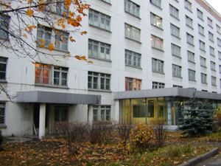
Moscow Research Institute of Psychiatry
Inter-regional site collaboration
Mutual exchange between the Mental Health Stream demonstration sites has been enhanced as a result of the CRDP. Keen interest has developed among the participants in learning from overall Program experience and experience of specific other demonstration sites, and in excelling in promoting community-oriented reforming of services. Examples follow.

- Close collaboration has been established between MRIP and all demonstration regions. In addition, increasing collaboration is being arranged between the regions, confirmed through formal bilateral collaboration agreements. This active “horizontal” collaboration network created a new type of Program participants’ community.
- Exchange learning visits, individual and team consultations, and larger-scale joint inter-regional learning events have been initiated, such as a professional learning visit exchange between Omsk and Stavropol (October 2004 and April 2005), exchange learning event in St. Petersburg involving professionals from Omsk (summer 2004), exchange visits between Ryazan and Tambov (April 2005), and many more.
- The All-Russia Society New Choices is implementing the Interregional Coordination project linked to CRDP. Chapters now exist in all demonstration sites and actively collaborate with participating professionals. Annual All-Russia conferences of the Society have involved Canadian consumer representatives (June 2004) and promoted wide interregional exchange. Exchange learning visits, individual and team inter-regional consultations have also been instrumental in strengthening the organization’s capacity.
- Two annual Mental Health Stream conferences on innovative service models involved all seven Program sites, and have also attracted professionals and consumers from across Russia (Omsk, April 2004 and St. Petersburg, June 2005).
- Demonstration models’ representatives are actively involved in professional conferences of regional and national level (a number of presentations and publications has been completed).
- The Program Mental Health Stream Website has been established, with links to all Program partners. The website includes regional demonstration sites’ sections.
- A broad resonance of the Program, and spreading of the accumulated knowledge and experience at the national level has led to wide involvement of neighboring and other regions across Russia.
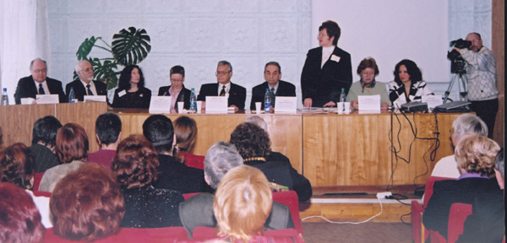
Inter-Regional Conference in Omsk (over 200 participants), April 2004

